**Assignment 2.2 Description**

**Submitted to: Dr. Vitaly**

**By: Tofik Mussa**

1. **Directory structure**

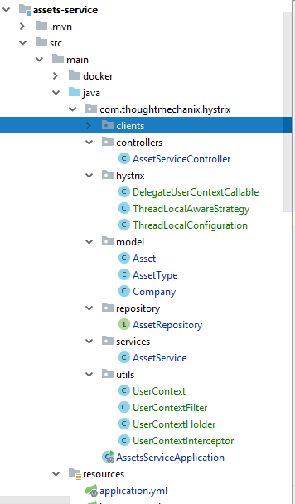

1. **Maven build**

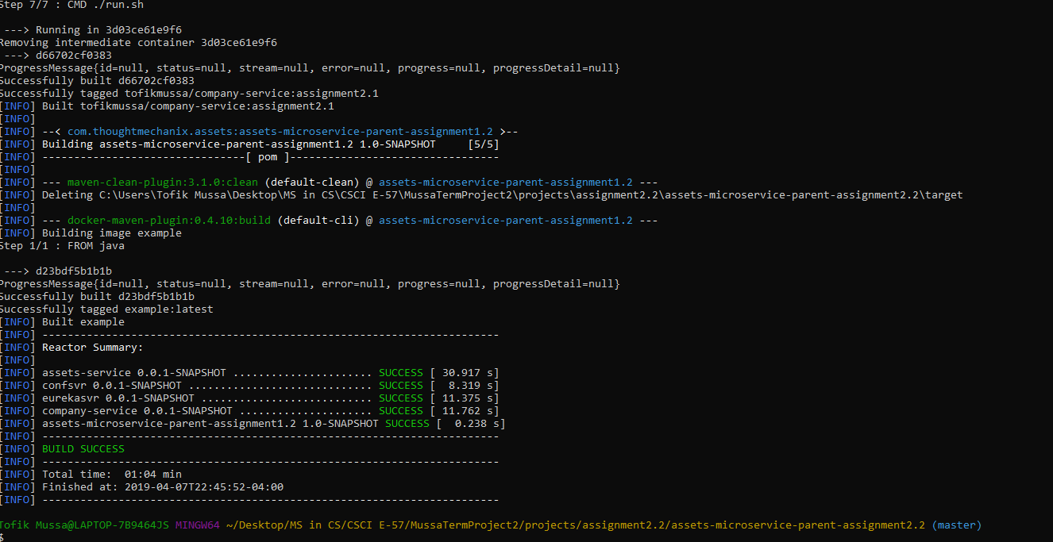

1. **Running docker compose**

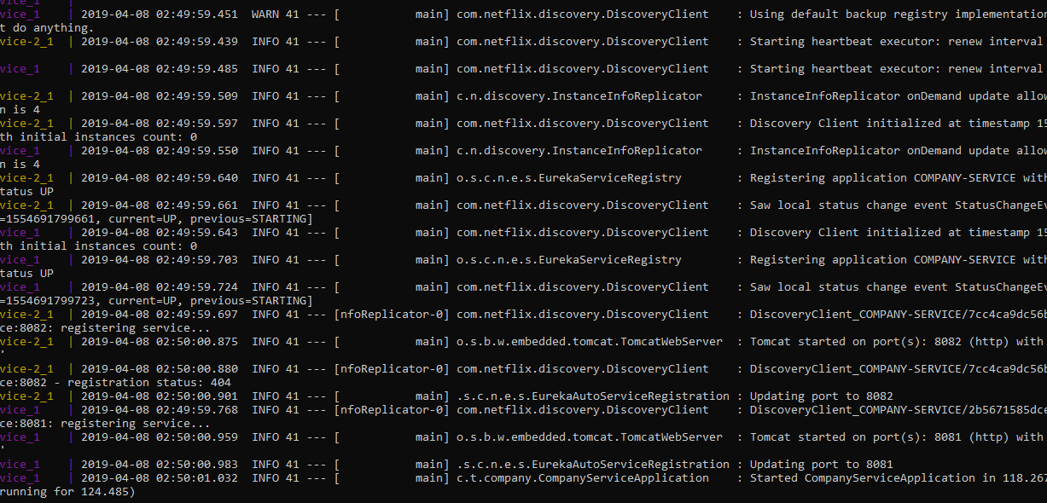

1. **Hitting the link errors out at first**

<http://192.168.99.100:8080/v1/companys/562f5ed0-b0bf-40cf-85c1-e560631057b8/assets/>

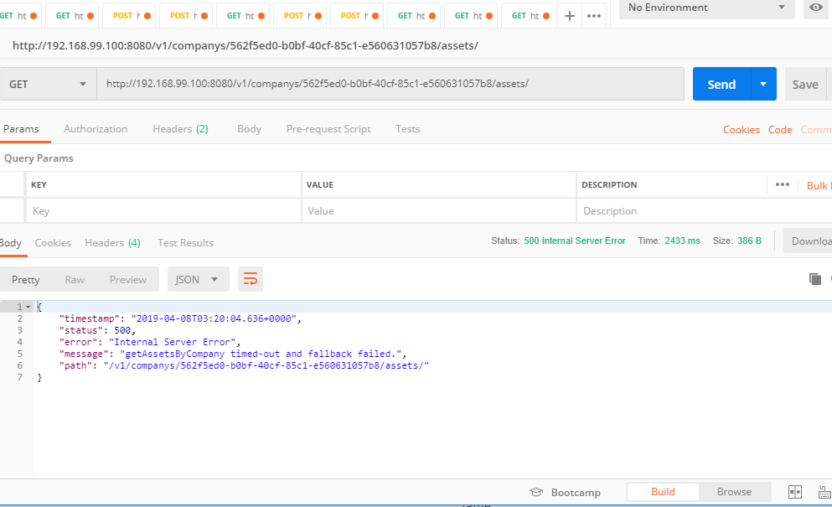

**Eventually a successful response**

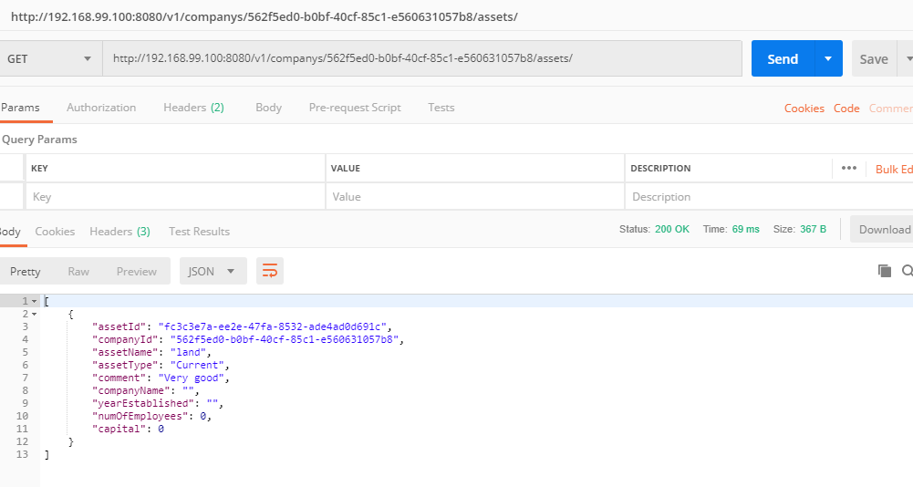

1. **After setting the waiting to 12 seconds, it never errors out**

<http://192.168.99.100:8080/v1/companys/562f5ed0-b0bf-40cf-85c1-e560631057b8/assets/>

